DATEROEM WOOD SALES
System Documentation
M-Pesa Payments
STK push, Send Money (B2C), reconciliation and going live
Document | M-Pesa Payments
Document number | DWS-BE-03
Version | 1.1
Date | 17 October 2026
Intended readers | The business owner, administrators and developers
Classification | Internal - contains system design details; share only with authorised staff
Explains every way money moves through the system, the safeguards around it, where each M-Pesa setting lives, and the exact steps to move from the Safaricom sandbox to real (production) payments.

Document control
Version | Date | Change
1.0 | 3 October 2026 | First complete edition, written from the source code as it stood on this date.
1.1 | 3 October 2026 | Send Money from the phone app: the admin check now uses the verified signed-in user on an approved phone.
1.1 | 8 October 2026 | Paybill or till is a setting (MPESA_TRANSACTION_TYPE, MPESA_PARTY_B); the production callback path /api/dateroem-payments without "mpesa"; going live on the hosted server (DWS-CFG-03).
1.1 | 9 October 2026 | Security review: a payment result counts only when Safaricom's status query confirms it; amounts must be positive whole shillings up to KES 1,000,000; Send Money and loan payments go to the number on file (another needs the SuperAdmin); failed payments are cleaned up either way.
1.1 | 17 October 2026 | M-Pesa customer payments live since 16 October 2026 (till 1804074, store 1334200); first live payment 17 October; the three faults fixed (sandbox address, old keys exported by start scripts, "mpesa" in the callback path); Send Money not live.
1.1 | 17 October 2026 | Where the M-Pesa receipt of a website payment is kept and shown (PRODUCT_PAYMENTS.Mpesa_Receipt; desktop Insights -> Website Payments).
Keep this document up to date: when a feature, setting or server changes, edit the matching section here and add a line to the table above.
Contents
1 Introduction 3
1.1 Live since 16 October 2026 3
1.2 Two directions of money 3
2 Where payments happen 5
3 Website checkout (STK push) 6
4 Staff STK push 8
5 Send Money (B2C) 9
5.1 Safeguards 9
6 Assigning incoming payments 11
7 Company SIM reconciliation 13
8 Callbacks and the public address 14
9 Status values 15
10 Configuration 16
11 Going live with real money 18
11.1 Obtain production credentials from Safaricom 18
11.2 Set the production values 18
11.3 Remove sandbox leftovers 18
11.4 Restart and verify 18
12 Troubleshooting 20
13 Files 21
14 Development history 22

1 Introduction
Dateroem uses Safaricom M-Pesa through the Daraja API for all electronic money. Customer payments are live since 16 October 2026: the Daraja app runs on the company till 1804074 (store 1334200), and the first live payment went through on 17 October. Send Money (B2C) is not live: a till cannot pay out, so payouts need a separate B2C shortcode from Safaricom; until then its settings are sandbox ones. This document explains how payments work and where every setting lives.

1.1 Live since 16 October 2026
Setting | Live value | Why
app.mpesa.base-url | https://api.safaricom.co.ke | The live Daraja; the backend adds /mpesa/stkpush/v1/processrequest itself
app.mpesa.shortcode | 1334200 | The store (head office) number - the passkey belongs to it
app.mpesa.transaction-type | CustomerBuyGoodsOnline | A till (Buy Goods), not a paybill
app.mpesa.party-b | 1804074 | The till customers pay into
app.mpesa.callback-url | https://<tunnel address>/api/dateroem-payments/stk | Live Daraja refuses addresses with "mpesa" in them
Consumer key, secret, passkey | the live app's (never in documents) | Kept in application.properties only

Caution: Never export MPESA_CONSUMER_KEY, MPESA_CONSUMER_SECRET (or any MPESA_ variable) in a start script or in the desktop Servers start command: an exported value wins over application.properties. On 16-17 October the start scripts still exported the old sandbox keys, so live Daraja refused every request until they were removed (17 October 2026; backups of the changed files are in /root, named *.before-live-2026-10-17).
The first live payment (an order of KES 5 on 17 October 2026) was marked PAID with its M-Pesa receipt; Safaricom's result reached /api/dateroem-payments/stk through the tunnel and was checked with Safaricom's status query before the order was marked paid.
Where the receipt is (since 17 October 2026): "the payment went through as a real one so why does the database not show the reference ... in the desktop" - the M-Pesa receipt of a website payment is kept in PRODUCT_PAYMENTS.Mpesa_Receipt (migration 035) and shown in the desktop app under Insights, Website Payments (every payment, searchable, double-click to copy the receipt) and in the Orders page's order list. A payment confirmed by Safaricom's status query instead of the callback has no receipt number - the list says so. ORDERS.Reference_ID is not the purchase receipt: it holds the receipt of a refund paid back to the customer.

1.2 Two directions of money
 | STK push (C2B) | Send Money (B2C)
Direction | Collects money FROM a customer into the company paybill | Pays money OUT of the company wallet to a person
Used for | Website orders; bulk-goods payments sent by staff | Paying expense entries, loan repayments and customer refunds
Who can start it | The customer at checkout; any signed-in staff member in Transactions | Admins and SuperAdmins only
Daraja endpoints | /mpesa/stkpush/v1/processrequest and /mpesa/stkpushquery/v1/query | /mpesa/b2c/v3/paymentrequest (CommandID BusinessPayment)
Result arrives at | /api/dateroem-mpesa-callback/stk (or a status query); production: /api/dateroem-payments/stk | /api/dateroem-mpesa-callback/b2c-result; production: /api/dateroem-payments/b2c-result
Table 1: STK push and Send Money compared

2 Where payments happen
Situation | Client and screen | Mechanism
Customer buys on the website | Website - Cart, then order status page | STK push for the order total; order rolled back if the push fails
Customer pays for a bulk (heavy) order | Mobile Transactions > Send STK Push; desktop Transactions | STK push by staff, then assigned to the bulk delivery
Paying an expense (transport, permits, salaries ...) | Mobile Expenses > Pay; desktop trip Expenses tab | Send Money (B2C) with automatic receipt
Repaying a loan | Mobile Loans & Finance > loan > Pay Loan; desktop loan dialog | Send Money; a repayment row is created and removed again if the payout fails
Refunding a dropped order | Mobile Transactions > Refunds; desktop Refunds | Send Money to the customer's phone (pre-filled)
Money paid while the system was offline | Company phone (SMS Sync) | M-Pesa SMS read and turned into transactions to assign
Cash (hard money) expenses | Expense form, "Paid with: Hard cash" | A transaction with a generated reference is recorded
Table 2: Where money moves

3 Website checkout (STK push)
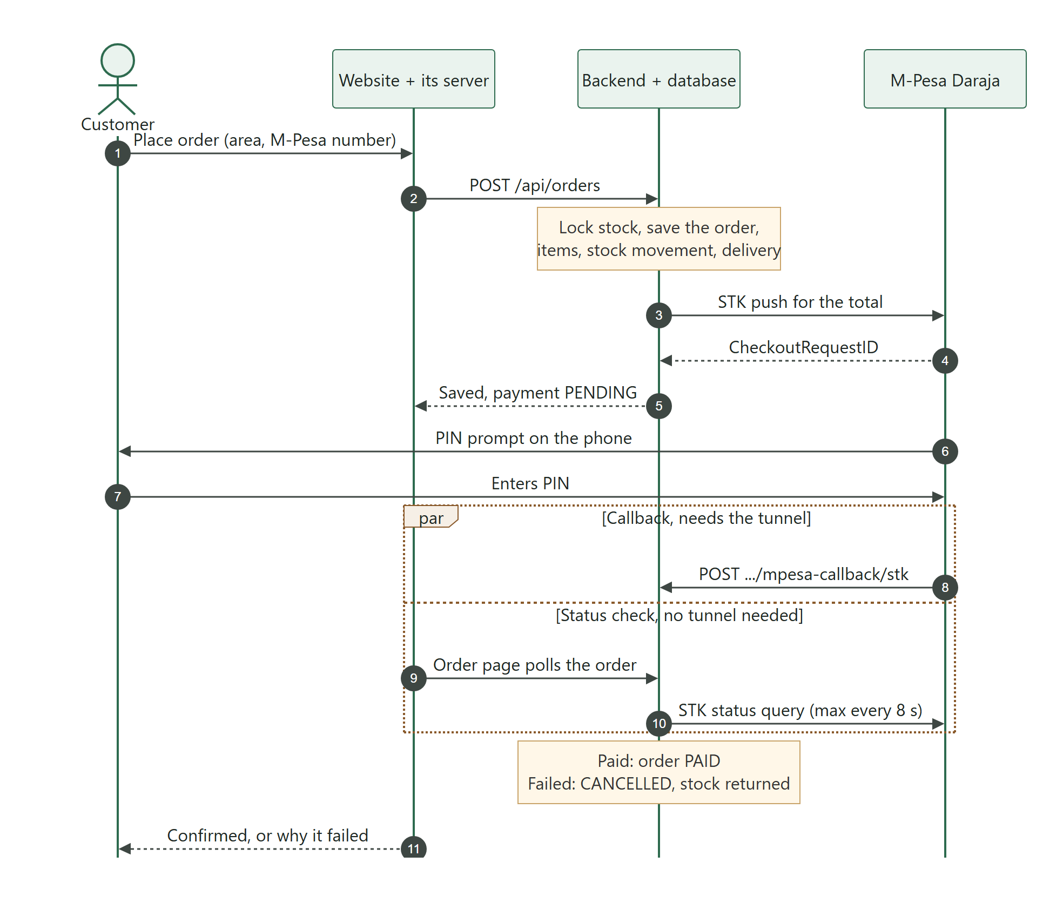
Figure 1: Website checkout with M-Pesa
- The customer must be signed in, choose an active delivery area and enter an M-Pesa number. The number is checked on the page and again on the server (07XXXXXXXX, 01XXXXXXXX or 2547XXXXXXXX; stored as 2547... with 12 digits).
- The backend locks the products, checks stock, saves the order and sends the STK push for the whole order total (whole shillings), with account reference ORD<order id>.
- If M-Pesa is not configured, the number is wrong, or Safaricom refuses the push, the order is rolled back completely - every order must be paid by M-Pesa.
- The order status page asks for the order every few seconds for about two minutes. Each request lets the backend ask Safaricom for the result (at most once every 8 seconds per payment, because Daraja allows only 30 requests a minute).
- The callback, when it arrives, carries the M-Pesa receipt number and wins. Success: PRODUCT_PAYMENTS becomes COMPLETED and the order PAID. Cancelled, timed out, wrong PIN or insufficient funds: the payment is FAILED, the order CANCELLED and the stock returned.

Caution: If a failure is noticed by the status query instead of the callback, the payment is marked FAILED but the order is not cancelled and its stock is not returned automatically. Keep the public tunnel running so callbacks arrive, and check for such orders until this is changed in OrderService.reconcilePendingPayment.

4 Staff STK push
Any signed-in staff member can send an STK push from Transactions (mostly for bulk goods). The backend records a FINANCIAL_TRANSACTION (mode STK_PUSH) with the CheckoutRequestID; the callback fills in the receipt. If no callback arrives, the person who sent it can confirm it by typing the receipt from the M-Pesa SMS. The payment then waits in the unassigned pool until an admin assigns it, usually to the bulk delivery's soft-cash amount.

5 Send Money (B2C)
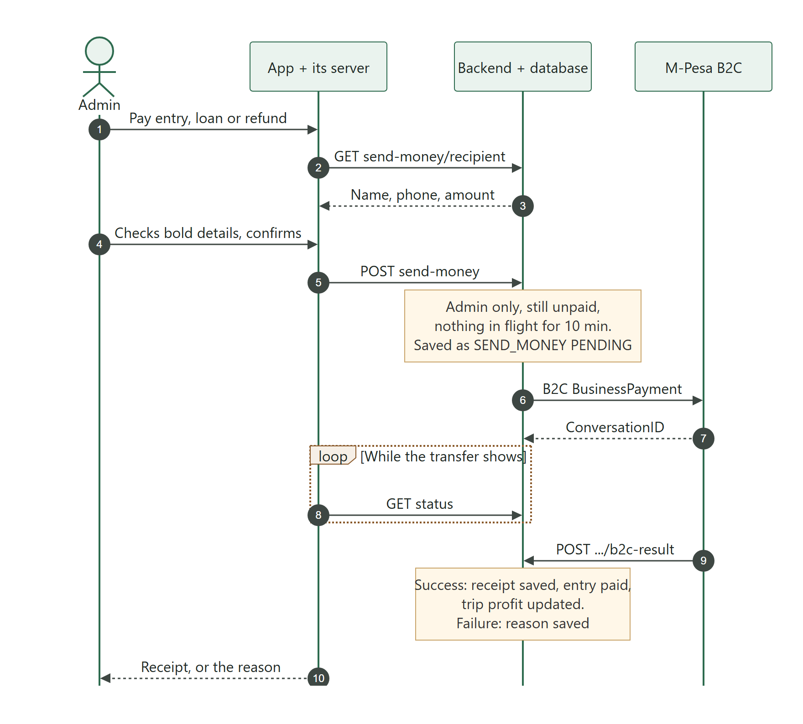
Figure 2: Paying an entry with Send Money

5.1 Safeguards
- Admins only - the backend checks the acting user's role. From the phone app, the acting user is the verified signed-in user on an approved phone (see the Backend Server document, Approved phones), so nobody can send money by claiming to be an admin.
- Pre-filled recipient - the name, phone and amount come from the entry itself (a farmer's phone, the salaried user, the vehicle driver, the lender, or the customer for refunds). The person only presses Send; "Edit" reveals the fields.
- Review step - every detail is shown in bold for confirmation before money leaves.
- One payout at a time - a second payout for the same entry within 10 minutes of a pending one is refused.
- Entry must still be unpaid - an entry already paid or deleted cannot be paid again.
- Results are confirmed with Safaricom (since 9 October 2026) - a result posted to the public callback address is never trusted on its own: the backend asks Safaricom with the authenticated status query and acts only on that answer, so a forged "paid" or "failed" message changes nothing.
- Amounts are checked - every prompt, payout and loan payment must be more than zero, in whole shillings and at most KES 1,000,000, before anything is recorded.
- Payout goes to the number on file - Send Money and loan payments must go to the recipient's number in the system; a different number needs the SuperAdmin and is written to the audit log. Entries with nobody on file still take a typed number.
- A failed payment is cleaned up - whether the failure arrives by callback or is found by the status query, the order is cancelled and its stock returned.
- Double-payment guard - a receipt number already recorded anywhere is rejected as a possible double payment.
- Automatic receipt - the result callback stores the receipt, marks the transaction COMPLETED, links it to the entry and recalculates the trip profit as the admin who sent it.
- Failures are explained - M-Pesa's own reason is stored and shown; a failed loan repayment is removed so the loan balance is not reduced.

Note: In the sandbox every payout is redirected to Safaricom's test number 254708374149 (the only number the sandbox pays). In production the real recipient number is used.
If the result callback never arrives (for example the tunnel was down), the app offers "Check again" and "I already have the M-Pesa receipt" to record the receipt by hand.

6 Assigning incoming payments
Incoming payments do not say what they were for. Staff record expenses as unpaid entries, and admins match payments to entries:
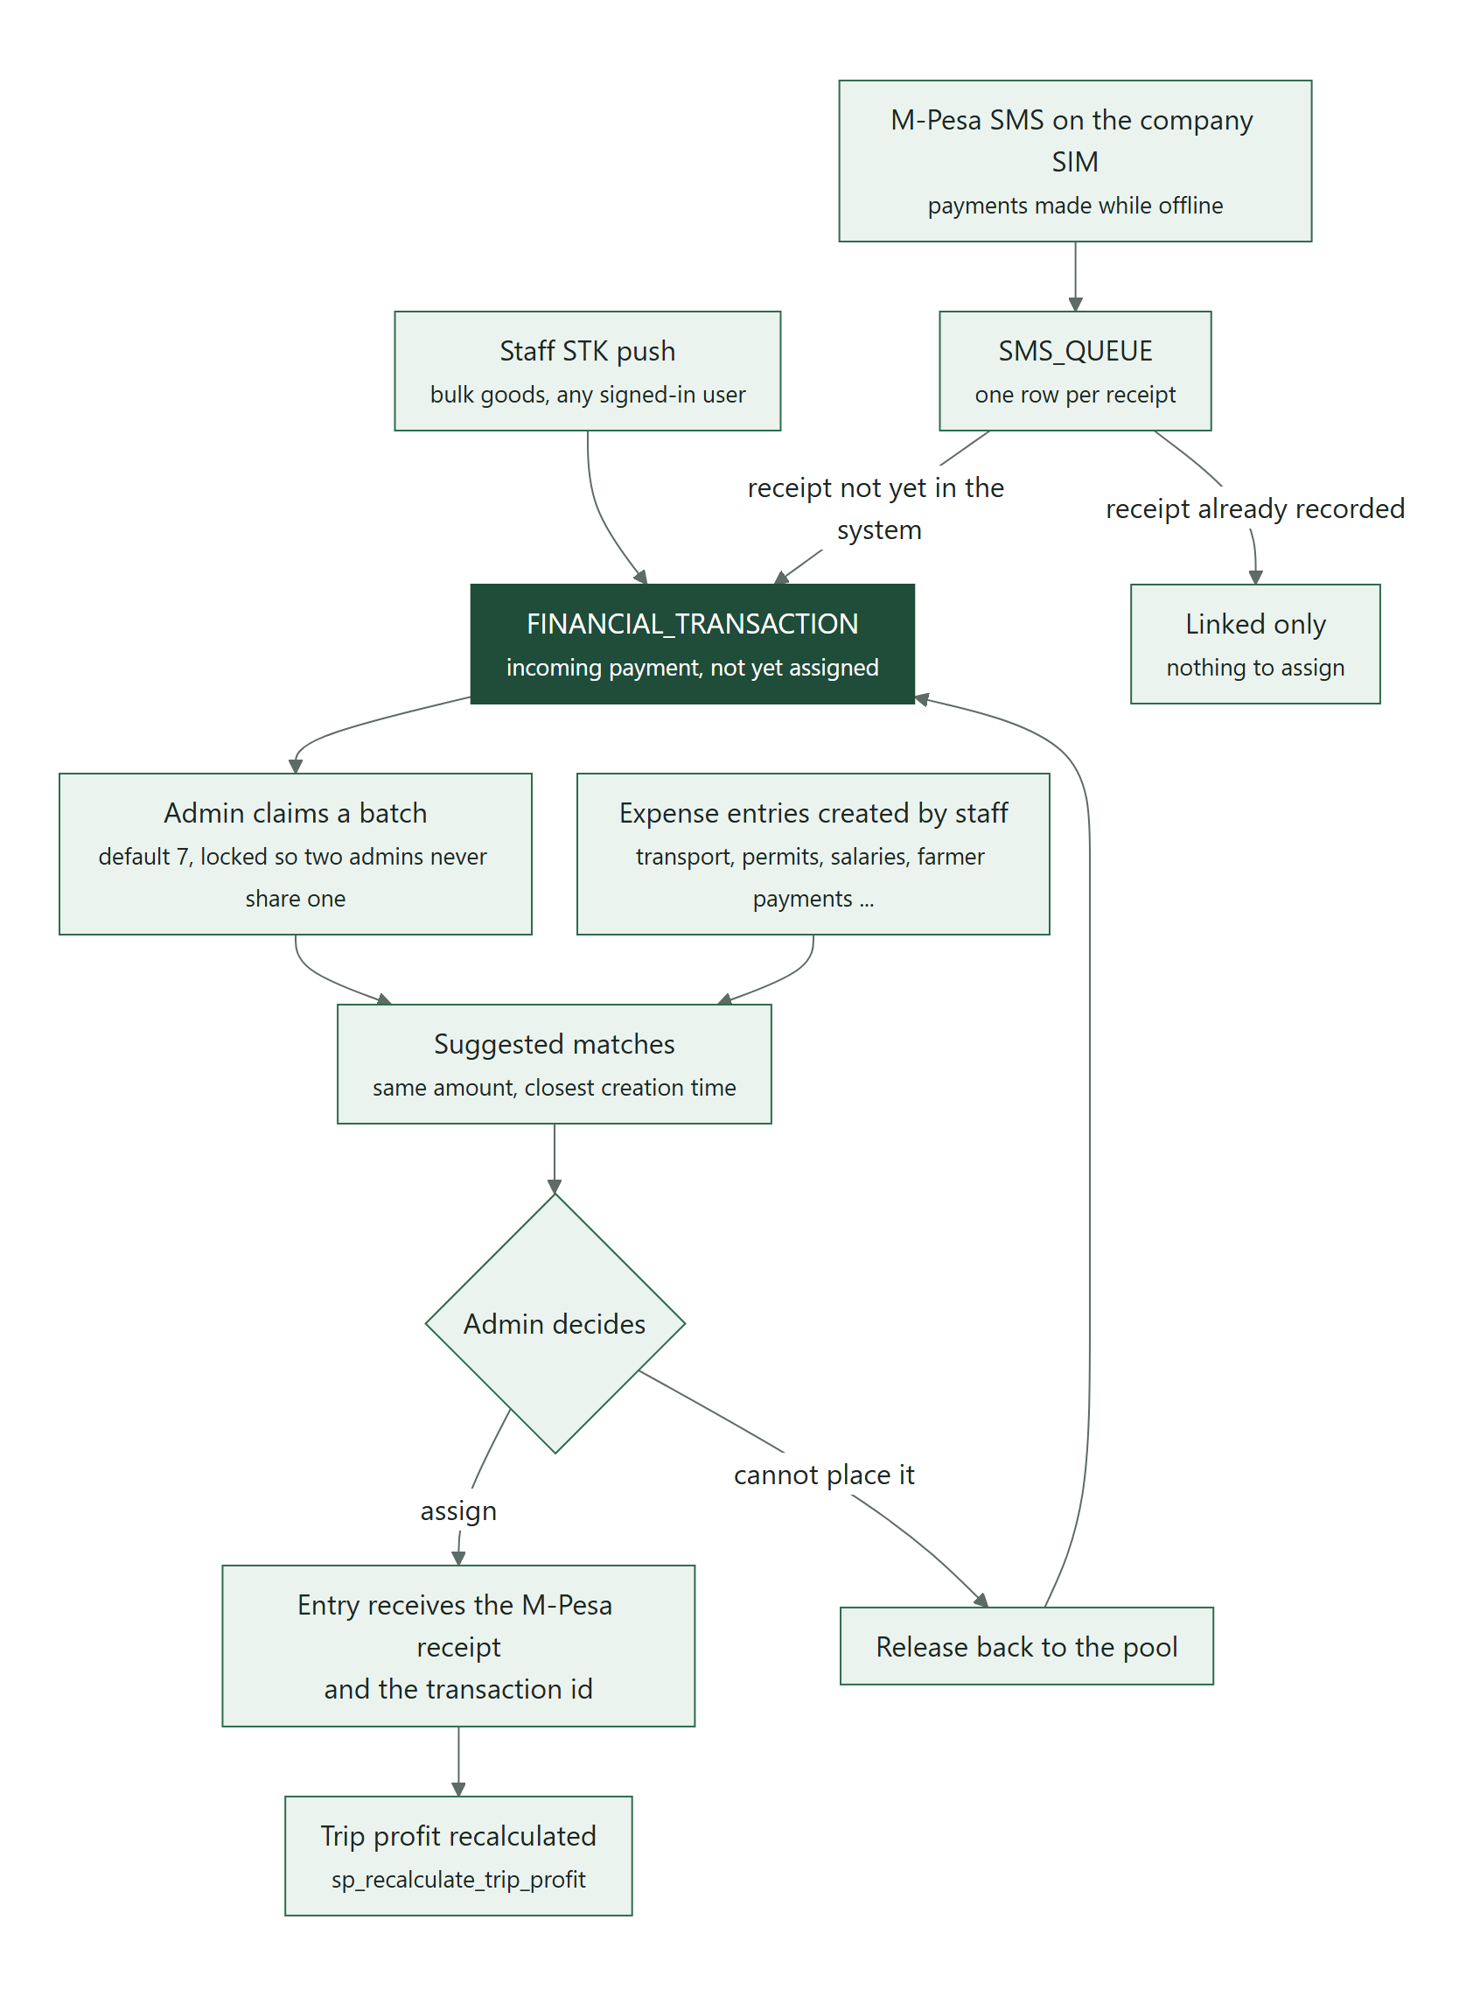
Figure 3: From an incoming payment to a paid expense entry
- Admins claim a batch (7 by default). Rows are locked with SKIP LOCKED so two admins never receive the same payment.
- For each payment the system suggests entries with exactly the same amount, ranked by how close their creation times are. The admin chooses; nothing is assigned automatically.
- Assigning writes the receipt and transaction id onto the entry and recalculates the trip profit. A payment that cannot be placed is released back to the pool.
- Loans and capital are filled in directly by admins and are never suggested as matches.

7 Company SIM reconciliation
The company phone (the one account allowed to sync SMS) reads every M-Pesa SMS on the company SIM, even when the app is closed, and posts it to the backend. Receipts already in the system are linked; unknown receipts become new unassigned transactions (mode SMS_QUEUE). This covers money sent while the system was offline. A sweep every 2 minutes catches anything missed. See the Mobile Application document (DWS-MOB-02) for the phone side.

8 Callbacks and the public address
Safaricom delivers results by calling a public HTTPS address. Today that is the reserved ngrok domain, which forwards to the Caddy router on port 9099; Caddy passes only /api/dateroem-mpesa-callback/* on to the backend. Since 8 October 2026 the same handlers also answer at /api/dateroem-payments/*: Safaricom rejects callback addresses containing words such as "M-PESA", so production uses that path (Hosting and Deployment Guide, DWS-CFG-03).
Callback | Address (path) | Set by
STK result | https://<public domain>/api/dateroem-payments/stk (sandbox: .../api/dateroem-mpesa-callback/stk also works) | MPESA_CALLBACK_URL
B2C result | https://<public domain>/api/dateroem-payments/b2c-result | MPESA_B2C_RESULT_URL
B2C time-out | same as the B2C result | MPESA_B2C_QUEUE_TIMEOUT_URL

If the tunnel is down, STK payments still settle through the status query, but B2C results do not arrive; use the manual receipt option or restart the tunnel (Servers section, "Public Tunnel").
Security: The callback endpoints are public and are not signed by Safaricom. They only act on CheckoutRequestIDs and ConversationIDs the system itself created, and webhook handlers never return errors to Safaricom. For production, consider allowing only Safaricom's published IP addresses at the router, or confirming each STK result with a status query before trusting it.

9 Status values
Where | Values | Meaning
FINANCIAL_TRANSACTION.Payment_Mode | STK_PUSH, SEND_MONEY, SMS_QUEUE, HARD | How the money moved
FINANCIAL_TRANSACTION.Status | PENDING, COMPLETED, FAILED | Payout progress; a row with a Reference_ID counts as COMPLETED
FINANCIAL_TRANSACTION.Category / Target_ID | an ExpenseTarget name and row id | What the payment was assigned to (empty = unassigned)
PRODUCT_PAYMENTS.Status | PENDING, COMPLETED, FAILED | Website order payment
ORDERS.Status | PENDING, PAID, CANCELLED | Order state
SMS_QUEUE.Status | NEW, MATCHED, PENDING_ASSIGNMENT | SMS reconciliation state

10 Configuration
All M-Pesa settings are properties in backend/src/main/resources/application.properties, each overridable by the environment variable named below. Secrets are supplied as environment variables by the launch scripts.
Environment variable | Property | Value today | Purpose
MPESA_BASE_URL | app.mpesa.base-url | https://api.safaricom.co.ke (live since 16 October 2026) | Daraja host. The sandbox is https://sandbox.safaricom.co.ke.
MPESA_CONSUMER_KEY | app.mpesa.consumer-key | the live app's, in application.properties (secret) | Daraja app consumer key. Not exported by any start script: an export would override the file.
MPESA_CONSUMER_SECRET | app.mpesa.consumer-secret | the live app's, in application.properties (secret) | Daraja app consumer secret. Not exported by any start script.
MPESA_SHORTCODE | app.mpesa.shortcode | 1334200 (the store) | Paybill number, or for a till the store (head office) number the passkey belongs to.
MPESA_TRANSACTION_TYPE | app.mpesa.transaction-type | CustomerBuyGoodsOnline (till) | Paybill (CustomerPayBillOnline) or till (CustomerBuyGoodsOnline). Since 8 October 2026.
MPESA_PARTY_B | app.mpesa.party-b | 1804074 (the till) | Till only: the till number customers pay into. Since 8 October 2026.
MPESA_PASSKEY | app.mpesa.passkey | the live passkey Safaricom sent for the store (secret) | Lipa na M-Pesa Online passkey. Production passkey comes from Safaricom.
MPESA_CALLBACK_URL | app.mpesa.callback-url | https://<tunnel address>/api/dateroem-payments/stk | Public HTTPS address Safaricom posts STK results to. Production: https://<domain>/api/dateroem-payments/stk (DWS-CFG-03).
MPESA_B2C_INITIATOR_NAME | app.mpesa.b2c-initiator-name | still a sandbox value (secret) | B2C (Send Money) initiator user name. Send Money is not live: a till cannot pay out.
MPESA_B2C_INITIATOR_PASSWORD | app.mpesa.b2c-initiator-password | Safaricom sandbox test password (secret) | B2C initiator password (encrypted with the certificate before sending).
MPESA_B2C_SHORTCODE | app.mpesa.b2c-shortcode | 1334200 (no B2C account yet) | B2C paying shortcode - needs a B2C (disbursement) shortcode from Safaricom.
MPESA_B2C_CERT_PATH | app.mpesa.b2c-cert-path | src/main/resources/mpesa/SandboxCertificate.cer (holds the production certificate since 16 October 2026; the name was kept) | Safaricom public certificate used to encrypt the initiator password (Send Money only).
MPESA_B2C_RESULT_URL | app.mpesa.b2c-result-url | https://<tunnel address>/api/dateroem-payments/b2c-result | Where Safaricom posts B2C results. Production: https://<domain>/api/dateroem-payments/b2c-result.
MPESA_B2C_QUEUE_TIMEOUT_URL | app.mpesa.b2c-queue-timeout-url | same as the result URL | Where Safaricom posts B2C time-outs.
Table 3: M-Pesa settings
Where to adjust: Since 17 October 2026 the M-Pesa keys and passkey are in application.properties only. The start scripts (/root/run_backend.sh, /root/start_backend.sh, C:\Scripts\Launch-Dateroem.bat and the backend start command in admin_server_control/desktop/app/core/server_manager.py) must not export any MPESA_ variable - an export overrides the file.
On the hosted server they go in /etc/dateroem/backend.env instead (DWS-CFG-03); there the file is the only source as well.
The system decides it is in the sandbox when MPESA_BASE_URL contains the word "sandbox". STK push is active when the consumer key and secret, shortcode, passkey and callback URL are all set. Send Money is active when the B2C initiator, shortcode, result URLs and an existing certificate file are also set; otherwise payouts are only recorded.

11 Going live with real money
Follow these steps in order. Do the first real transactions with small amounts.

11.1 Obtain production credentials from Safaricom
- On developer.safaricom.co.ke, use "Go Live" for the Dateroem app with the company's M-Pesa paybill (or till) number. This needs the organisation's M-Pesa administrator and business documents (the list, the callback addresses and the order of steps are in DWS-CFG-03, "Safaricom M-Pesa: going live").
- Collect the production consumer key and consumer secret of the live app.
- Collect the Lipa na M-Pesa Online passkey that Safaricom sends for the live shortcode.
- For Send Money, create an API initiator user on the M-Pesa organisation portal for the B2C shortcode, and note its name and password.
- Download Safaricom's production public certificate from the Daraja portal and save it on the server - on the hosted server /etc/dateroem/mpesa/ProductionCertificate.cer.
- Arrange a permanent public HTTPS address for callbacks: the company domain on the hosted server (DWS-CFG-03).

11.2 Set the production values
On the hosted server, fill these in /etc/dateroem/backend.env (same names, without "export"; DWS-CFG-03). On the company computer, export them in each launch script listed above (values come from Safaricom - never write them into documents):
export MPESA_BASE_URL=https://api.safaricom.co.ke
export MPESA_CONSUMER_KEY=<production consumer key>
export MPESA_CONSUMER_SECRET=<production consumer secret>
export MPESA_SHORTCODE=<paybill number, or the till's store number>
export MPESA_TRANSACTION_TYPE=CustomerPayBillOnline # till: CustomerBuyGoodsOnline
export MPESA_PARTY_B=<till number; leave empty for a paybill>
export MPESA_PASSKEY=<production passkey>
export MPESA_CALLBACK_URL=https://<public domain>/api/dateroem-payments/stk
export MPESA_B2C_INITIATOR_NAME=<initiator name>
export MPESA_B2C_INITIATOR_PASSWORD=<initiator password>
export MPESA_B2C_SHORTCODE=<B2C shortcode>
export MPESA_B2C_CERT_PATH=/root/fathersProject/backend/src/main/resources/mpesa/ProductionCertificate.cer
export MPESA_B2C_RESULT_URL=https://<public domain>/api/dateroem-payments/b2c-result
export MPESA_B2C_QUEUE_TIMEOUT_URL=https://<public domain>/api/dateroem-payments/b2c-result

11.3 Remove sandbox leftovers
- In application.properties, delete the sandbox defaults after the colons for the passkey, B2C initiator name and password, B2C shortcode and callback URLs, so a missing variable fails safely instead of falling back to sandbox values.
- If the company uses a till number (Buy Goods) instead of a paybill: since 8 October 2026 this is a setting - MPESA_TRANSACTION_TYPE=CustomerBuyGoodsOnline, MPESA_SHORTCODE the store number and MPESA_PARTY_B the till number (MpesaClient.initiateStkPush reads them). No code change.
- Salaries are paid with CommandID BusinessPayment today. If Safaricom requires SalaryPayment for salaries on the live account, change it in MpesaClient.initiateB2C.

11.4 Restart and verify
- Restart the backend (desktop Servers section, Backend, Stop then Start).
- Place a small website order and confirm the PIN prompt, the PAID status and the receipt in PRODUCT_PAYMENTS.
- Pay a small expense entry with Send Money to a known phone and confirm the receipt arrives automatically.
- Check the backend log for Daraja errors.

Security: Before switching on real money, complete the security items in the Production Go-Live Checklist (DWS-CFG-02) - in particular verified identities for Send Money and the other admin actions.

12 Troubleshooting
Symptom or code | Meaning | What to do
"M-Pesa isn't configured on the server" | A required M-Pesa variable is missing | Check the exports in the launch script and restart the backend
400.002.02 Invalid CallBackURL | The callback URL is not a reachable public HTTPS address, or (production) it contains a word Safaricom rejects, such as "mpesa" | Check MPESA_CALLBACK_URL and that the tunnel (or the hosted server) is reachable; in production use /api/dateroem-payments/stk
"Safaricom rejected the app credentials" | Wrong or expired consumer key or secret | Re-copy them from the Daraja app
Live: no prompt reaches the phone at all | A start script exports an old (sandbox) key that overrides application.properties, or MPESA_BASE_URL still points at the sandbox | Remove every MPESA_ export from the start scripts; base-url https://api.safaricom.co.ke; restart the backend (17 October 2026)
"Invalid CallBackURL" | The callback address contains a refused word ("mpesa") or is not public HTTPS | Use https://<address>/api/dateroem-payments/stk
ResultCode 1032 | Customer cancelled the prompt | Customer places the order again
ResultCode 1037 | Prompt timed out unanswered | Phone off or no network; try again
ResultCode 1 / 2001 | Insufficient funds / wrong PIN | Customer retries
HTTP 429 SpikeArrestViolation | More than 30 Daraja calls a minute | Normal under load; status checks are already spaced 8 s apart
"Initiator Information is invalid" | Certificate does not match the environment, or wrong initiator password | Use the certificate for the same environment as MPESA_BASE_URL
ResultCode 8006 | Security credential locked after repeated wrong attempts | Reset the initiator password on the M-Pesa portal
"Credit Party customer type can't be supported" | Sandbox payout to a number other than the test number | Expected in the sandbox only
Connection reset or time-out | This network sometimes reaches a dead Safaricom address | Requests are retried automatically; a payment is never resent after it may have been received

13 Files
File | Role
backend/.../service/MpesaClient.java | All Daraja calls: token, STK push, status query, B2C, phone validation, certificate encryption
backend/.../service/TransactionService.java | Staff STK push, Send Money, Pay Loan, callbacks, assignment, double-payment guard
backend/.../service/OrderService.java | Website checkout payment, status reconciliation, drop and refund
backend/.../controller/MpesaCallbackController.java | Public callback endpoints
backend/.../service/SmsQueueService.java | SMS reconciliation
backend/.../model/ExpenseTarget.java | Every payable category and its table
frontend/website/src/pages/CartPage.jsx, OrderConfirmationPage.jsx | Website payment form and status polling
mobile app ui/transactions/* (PayoutController, PayoutContent, StkPushScreen, RefundsScreen, SmsSyncScreen) | Phone payment screens
desktop app ui/widgets/payout_dialog.py, transfer_scene.py | Desktop payment confirmation and animation
Caddyfile | Public route for callbacks

14 Development history
Date | Change
2026-09-12 | Expenses with admin assignment of payments, Capital, Loans and Finance, heavy (bulk) orders, date pickers.
2026-09-13 | M-Pesa Send Money (B2C) in the sandbox, including Safaricom's encryption certificate.
2026-09-17 | Public access through ngrok, phone-friendly layout, Google Analytics behind cookie consent, side-panel help chat, cart icon, M-Pesa STK push at checkout (sandbox).
2026-09-18 | STK payment confirmed end to end (callback and status query), Ordered Goods page, customer-specific order numbers, size-based delivery estimates.
2026-09-19 | Send Money for expenses with automatic receipts (no typing), loan details and Pay Loan, transfer animation with a bold confirmation step.
2026-09-20 | Bulk delivery editing, company-SIM M-Pesa SMS reading into the SMS queue, delivery signature.
2026-09-20 | Drop and refund of orders not yet on a trip.
2026-09-23 | Connectivity fixes; 14-point manual-test fix list; only one phone may read company SMS.
2026-09-24 | No order without a successful payment prompt, phone number checked before paying, cart kept on refresh, full-page delivery area picker with "near me" and map coordinates, product grid, Ordered Goods cards.
2026-10-08 | Ready for Go Live by settings alone: paybill or till chosen with MPESA_TRANSACTION_TYPE and MPESA_PARTY_B (no code edit), and the M-Pesa callbacks also answer at /api/dateroem-payments, a production address without "mpesa" in it (Safaricom rejects such addresses).
2026-10-09 | Security review before going public: a payment result counts only when Safaricom's own status query confirms it, never the message posted to the public callback address; order quantities must be whole numbers of 1 or more, and the same product twice is added together before the stock check; the phone app accepts staff accounts only; the servers' API description pages are off; payout amounts must be positive whole shillings up to KES 1,000,000; Send Money and loan payments go to the number on file (another number needs the SuperAdmin); a failed payment is cleaned up (order cancelled, stock returned) however the failure is seen.
2026-10-16 | M-Pesa live: the Daraja app went live on the company till 1804074 (store 1334200) with the live keys and passkey.
2026-10-17 | First live STK payment (KES 5, receipt received, result delivered to /api/dateroem-payments/stk and checked with Safaricom). Fixed on the way: the Daraja address still pointed at the sandbox, the start scripts exported the old sandbox keys (which override application.properties), and the callbacks used a path with "mpesa" in it. Send Money is not live: a till cannot pay out.
2026-10-17 | Migration 035: PRODUCT_PAYMENTS.Mpesa_Receipt - the M-Pesa receipt of a website payment in its own column (filled for earlier payments from their description).
2026-10-17 | M-Pesa receipts visible: Insights -> Website Payments lists every website payment with its receipt (search, double-click to copy), and the Orders page shows each order's receipt.
2026-10-17 | Migration 036: USERS.Phone_Verified_At and PHONE_VERIFICATIONS - phone numbers confirmed by an SMS code.
2026-10-17 | Phone numbers confirmed by an SMS code (Africa's Talking): a 6-digit code at sign-up (password or Google) and, for accounts made before, once before the first order; checkout fills in only a confirmed number. Live for Airtel numbers only until Dateroem has its own SMS sender name; other numbers are taken as typed, as before.
2026-10-18 | After a restart of the computer the servers were found stopped (website and payments offline); they can now be started in the background without the desktop app (/root/dateroem_start).

